Revised Boat Arrival/Departure
RIB/Road Trailer Parking
RIB Launching

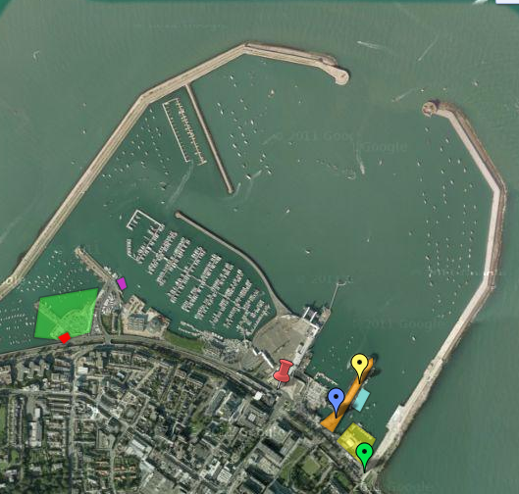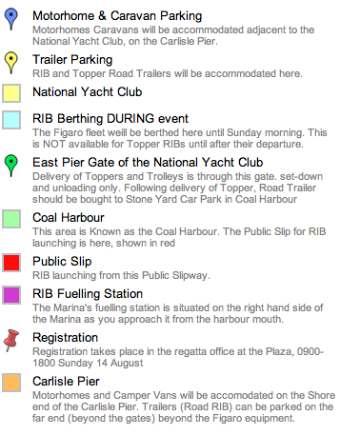

Toppers & Launching Tolleys
Arrival: Deliver to National Yacht Club through East Pier gate any day Tues 9th to Sunday 14th. Part of the car park in front of the NYC will be blocked off on Saturday 13 and Sunday 14 August and used as a transition stage to off-load Toppers and launching trolleys.
Departure: Toppers on Trolleys should be wheeled to the Carlisle Pier, where they can be loaded onto trailers.

Topper - Boat Parking
Competitor boat parking will be on the platform in front of the Club. Each competitor will be allocated a specific parking space on registration and they must use that space for the entire event.

Topper Road Trailers
Arrival: After delivery of the Topper & Trolley to the NYC, Road Trailers should be taken to the far end of the Carlisle Pier (beyond the midway railings) . The Carlisle Pier will al;so be the As this will be the loading zone at the end of the event.

RIB Launching & Berthing
RIBs can launch anytime from public slip in the Coal Harbour. See interactive map on Event Website for exact location.

For those who wish to keep a RIB afloat prior to event, private arrangements can be made with Dun Laoghaire Marina (http://www.dlmarina.com) to berth there, at a cost per night. Otherwise RIBs can be retrieved each evening on public slip.

During the event, from noon on Sunday 14th, RIBs can be moored on the pontoon on the east side of the Carlisle Pier, in front of the National Yacht Club.
RIB owners are reminded to register their RIB at the registration desk in the Regatta Office at the Plaza on Sunday 14 August. RIBs will be identified by flags, as either Safety/Rescue, or Support/Spectator. These identification flags must be flown at all times while in the Race Area.
RIB Trailers
After launching RIB, proceed to deliver trailer to the trailer storage area on the Carlisle Pier (beyond the midway railings).

Security
Visitors are reminded that this is a City venue. Open vehicles or equipment should not be left unattended. Vehicles should be locked when unoccupied. Road and RIB trailers should also have a lock fitted and locked when not in use. The organisers cannot take responsibility for loss or damage.

